# Project Overview

* **Project Title:** Bank Loan Analysis

The objective of this project was to analyze a bank’s loan dataset using SQL and Power BI to uncover **key performance indicators (KPIs)** and identify trends in lending and repayments. Specifically, the analysis aimed to:

* Determine overall **loan portfolio performance**:
  + Total Loan Applications
  + Total Funded Amount
  + Total Amount Received (repayments)
  + Average Interest Rate
  + Average Debt-to-Income Ratio (DTI)
* Identify **trends and patterns** in lending:
  + Loan status distribution (Fully Paid, Current, Charged Off, etc.)
  + Monthly trend of loan applications, funded amounts, and repayments
  + Loan performance by **term** (36 months vs 60 months)
* Understand **borrower and loan characteristics**:
  + Loan distribution by **purpose** (e.g., debt consolidation, small business, credit card, etc.)
  + Loan performance by **home ownership status**
  + Loan grade/subgrade distribution and performance
* Provide **insightful comparisons**:
  + Geographic distribution of loans

This analysis helps stakeholders evaluate the **credit risk profile**, optimize **loan approval strategies**, and improve **collections and recovery processes**.

# Data Description

**Database Name:** coffee_shop_sales_db

**Tables Used:** coffee_shop_sales

* Id→ Unique identifier
* address_state→ State of location
* Application_type→ Type of the application
* emp_length→ Amount of time the applicant is employed
* emp_title→ Title of the employment of the applicant
* grade→ Grade of the application
* home_ownership→ Status of the applicants accomodation
* issue_date→ Date of the loan issued
* last_credit_pull_date→ Last date of the credit pull of the applicant
* last_payment_date→ Last date of the payment done by the applicant
* loan_status→ Status of the loan(Charged off, Current, Fully paid)
* next_payment_date→ Next date of payment
* member_id→ Unique member identification of the applicant
* purpose→ Purpose of taking the loan
* sub_grade→ Sub division of the grade of the loan
* term→ Term of repay(36 months, 60 months)
* verification_status→ (Not verified, Source verified, Verified)
* annual_income→ Annual income of the applicant
* dti→ Debt to income ratio
* installment→ Number of installments
* int_rate→ Interest Rate
* loan_amount→ Amount of loan issued to the applicant
* total_payment→ Total amount repaid by the applicant

**Time Period Covered:** 1st January 2021 - 12 December 2021

**Number of Records:** 38576 Records

# Data Preparation

**Data Cleaning Steps:**

* Checked for missing values where necessary (NULL).
* Removed duplicate records.
* Converted date formats using STR_TO_DATE().

# SQL Analysis Queries

### KPI’s:

#### Total Loan Applications

SELECT COUNT(id) AS Total_Applications FROM bank_loan_data



#### MTD Loan Applications

SELECT COUNT(id) AS Total_Applications FROM bank_loan_data

WHERE MONTH(issue_date) = 12



#### **PMTD Loan Applications** SELECT COUNT(id) AS Total_Applications FROM bank_loan_data

WHERE MONTH(issue_date) = 11



#### Total Funded Amount

SELECT SUM(loan_amount) AS Total_Funded_Amount FROM bank_loan_data



#### MTD Total Funded Amount

SELECT SUM(loan_amount) AS Total_Funded_Amount FROM bank_loan_data

WHERE MONTH(issue_date) = 12



#### PMTD Total Funded Amount

SELECT SUM(loan_amount) AS Total_Funded_Amount FROM bank_loan_data

WHERE MONTH(issue_date) = 11



#### Total Amount Received

SELECT SUM(total_payment) AS Total_Amount_Collected FROM bank_loan_data



#### MTD Total Amount Received

SELECT SUM(total_payment) AS Total_Amount_Collected FROM bank_loan_data

WHERE MONTH(issue_date) = 12



#### PMTD Total Amount Received

SELECT SUM(total_payment) AS Total_Amount_Collected FROM bank_loan_data

WHERE MONTH(issue_date) = 11



#### Average Interest Rate

SELECT AVG(int_rate)*100 AS Avg_Int_Rate FROM bank_loan_data



#### MTD Average Interest

SELECT AVG(int_rate)*100 AS MTD_Avg_Int_Rate FROM bank_loan_data

WHERE MONTH(issue_date) = 12



#### PMTD Average Interest

SELECT AVG(int_rate)*100 AS PMTD_Avg_Int_Rate FROM bank_loan_data

WHERE MONTH(issue_date) = 11



#### Avg DTI

SELECT AVG(dti)*100 AS Avg_DTI FROM bank_loan_data



#### MTD Avg DTI

SELECT AVG(dti)*100 AS MTD_Avg_DTI FROM bank_loan_data

WHERE MONTH(issue_date) = 12



#### PMTD Avg DTI

SELECT AVG(dti)*100 AS PMTD_Avg_DTI FROM bank_loan_data

WHERE MONTH(issue_date) = 11



### GOOD LOAN ISSUED

#### Good Loan Percentage

SELECT

(COUNT(CASE WHEN loan_status = 'Fully Paid' OR loan_status = 'Current' THEN id END) * 100.0) /

COUNT(id) AS Good_Loan_Percentage

FROM bank_loan_data



#### Good Loan Applications

SELECT COUNT(id) AS Good_Loan_Applications FROM bank_loan_data

WHERE loan_status = 'Fully Paid' OR loan_status = 'Current'



#### Good Loan Funded Amount

SELECT SUM(loan_amount) AS Good_Loan_Funded_amount FROM bank_loan_data

WHERE loan_status = 'Fully Paid' OR loan_status = 'Current'



#### Good Loan Amount Received

SELECT SUM(total_payment) AS Good_Loan_amount_received FROM bank_loan_data

WHERE loan_status = 'Fully Paid' OR loan_status = 'Current'



### BAD LOAN ISSUED

#### Bad Loan Percentage

SELECT

(COUNT(CASE WHEN loan_status = 'Charged Off' THEN id END) * 100.0) /

COUNT(id) AS Bad_Loan_Percentage

FROM bank_loan_data



#### Bad Loan Applications

SELECT COUNT(id) AS Bad_Loan_Applications FROM bank_loan_data

WHERE loan_status = 'Charged Off'



#### Bad Loan Funded Amount

SELECT SUM(loan_amount) AS Bad_Loan_Funded_amount FROM bank_loan_data

WHERE loan_status = 'Charged Off'



#### Bad Loan Amount Received

SELECT SUM(total_payment) AS Bad_Loan_amount_received FROM bank_loan_data

WHERE loan_status = 'Charged Off'



### LOAN STATUS

SELECT

loan_status,

COUNT(id) AS LoanCount,

SUM(total_payment) AS Total_Amount_Received,

SUM(loan_amount) AS Total_Funded_Amount,

AVG(int_rate * 100) AS Interest_Rate,

AVG(dti * 100) AS DTI

FROM

bank_loan_data

GROUP BY

loan_status

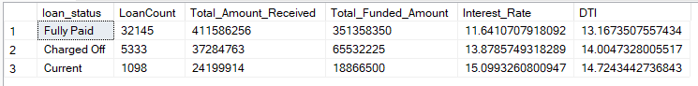

SELECT

loan_status,

SUM(total_payment) AS MTD_Total_Amount_Received,

SUM(loan_amount) AS MTD_Total_Funded_Amount

FROM bank_loan_data

WHERE MONTH(issue_date) = 12

GROUP BY loan_status

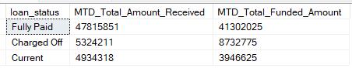

### MONTH

SELECT

MONTH(issue_date) AS Month_Munber,

DATENAME(MONTH, issue_date) AS Month_name,

COUNT(id) AS Total_Loan_Applications,

SUM(loan_amount) AS Total_Funded_Amount,

SUM(total_payment) AS Total_Amount_Received

FROM bank_loan_data

GROUP BY MONTH(issue_date), DATENAME(MONTH, issue_date)

ORDER BY MONTH(issue_date)

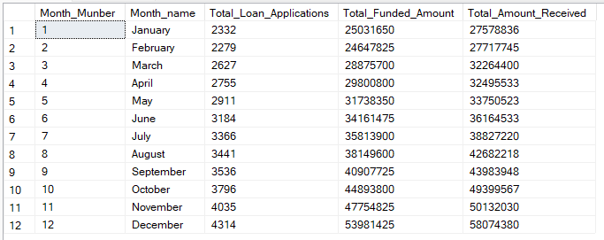

### STATE

SELECT

address_state AS State,

COUNT(id) AS Total_Loan_Applications,

SUM(loan_amount) AS Total_Funded_Amount,

SUM(total_payment) AS Total_Amount_Received

FROM bank_loan_data

GROUP BY address_state

ORDER BY address_state

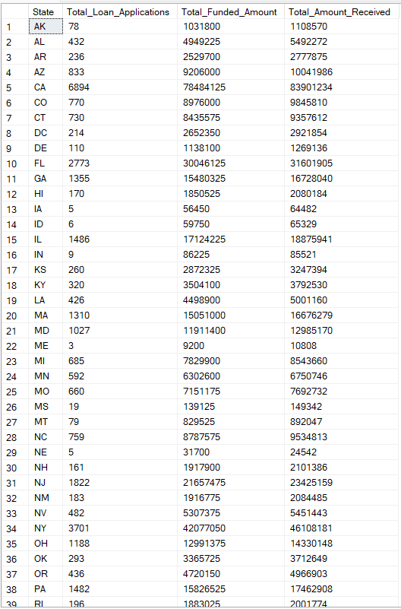

### TERM

SELECT

term AS Term,

COUNT(id) AS Total_Loan_Applications,

SUM(loan_amount) AS Total_Funded_Amount,

SUM(total_payment) AS Total_Amount_Received

FROM bank_loan_data

GROUP BY term

ORDER BY term

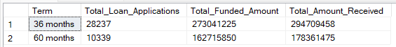

### EMPLOYEE LENGTH

SELECT

emp_length AS Employee_Length,

COUNT(id) AS Total_Loan_Applications,

SUM(loan_amount) AS Total_Funded_Amount,

SUM(total_payment) AS Total_Amount_Received

FROM bank_loan_data

GROUP BY emp_length

ORDER BY emp_length

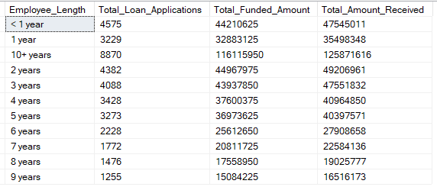

### PURPOSE

SELECT

purpose AS PURPOSE,

COUNT(id) AS Total_Loan_Applications,

SUM(loan_amount) AS Total_Funded_Amount,

SUM(total_payment) AS Total_Amount_Received

FROM bank_loan_data

GROUP BY purpose

ORDER BY purpose

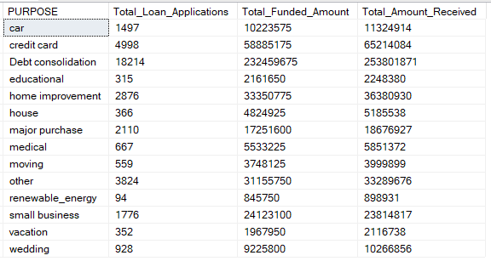

### HOME OWNERSHIP

SELECT

home_ownership AS Home_Ownership,

COUNT(id) AS Total_Loan_Applications,

SUM(loan_amount) AS Total_Funded_Amount,

SUM(total_payment) AS Total_Amount_Received

FROM bank_loan_data

GROUP BY home_ownership

ORDER BY home_ownership

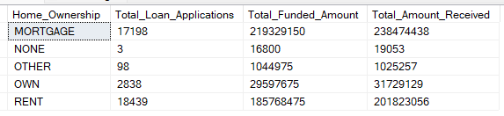

# Key Findings & Insights

* More than 85% loans issued were considered “Good Loan” and generating profit for the bank.
* Highest amount of loans issued to people who were 10+ years employed.
* The top reason for taking a loan was “Debt Consolidation”.
* Most applicants are from the state of California.